Assignment 9 – Chapter X

1. Find the first partial derivatives of the function.
$$z=\ln{(x+t^{2})}$$
Solution
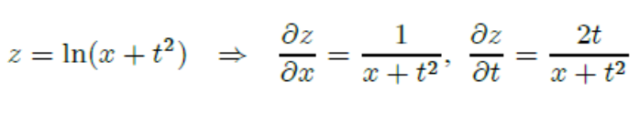
2. Find all the second partial derivatives.
$$f\left(x,y\right)=x^{4}y-2x^{3}y^{2}$$
Solution
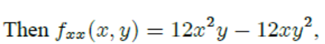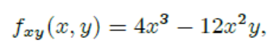

3. Classify all stationary points of the given function.
$$\left(a\right)f\left(x,y\right)=y(e^{x}-1)$$
$$\left(b\right)f\left(x,y\right)=y\cos{x}$$

Solution
(a)
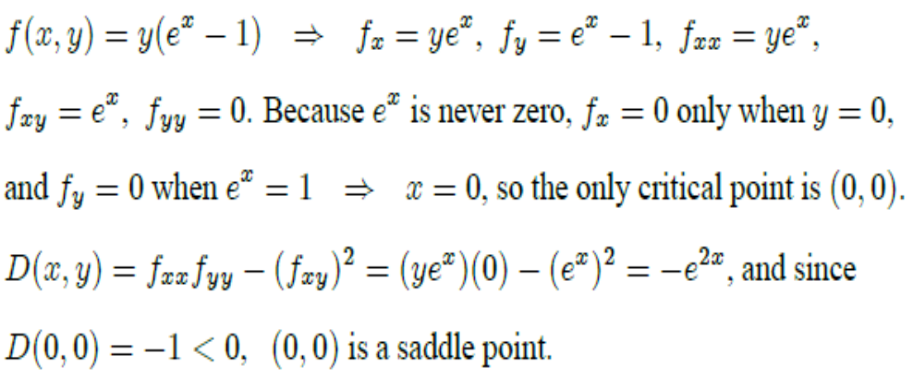
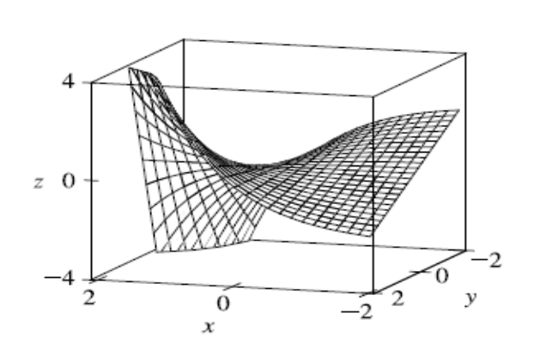
(b)
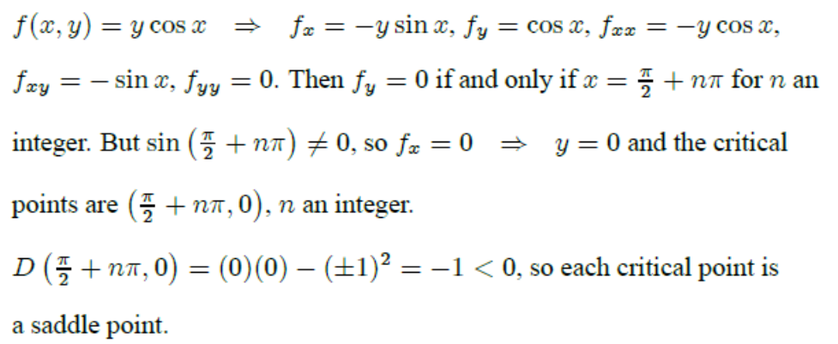
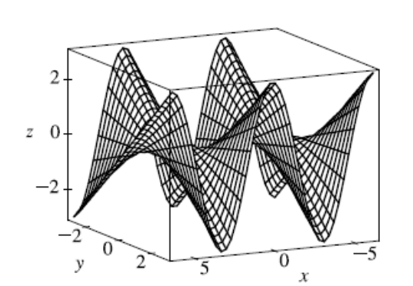

4. Find the absolute maximum and minimum values of f on the set D.
$f\left(x, y\right)=x+y-xy$, D is the closed triangular region with vertices (0, 0), (0, 2) and (0, -2).
Solution

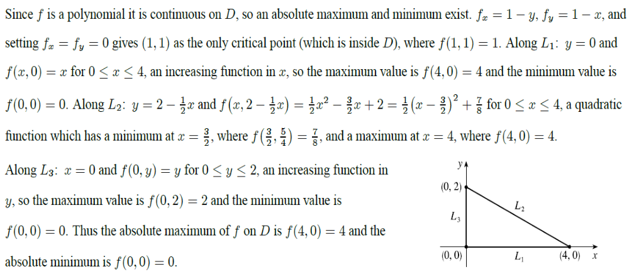
5. Find the shortest distance from the point (2, 0, -3) to the plane x + y + z = 1.
Solution
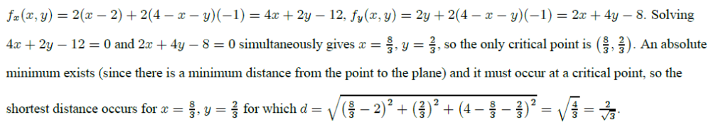

6. Find the dimensions of the box with volume 1000 cm³ that has minimal surface area.
Solution
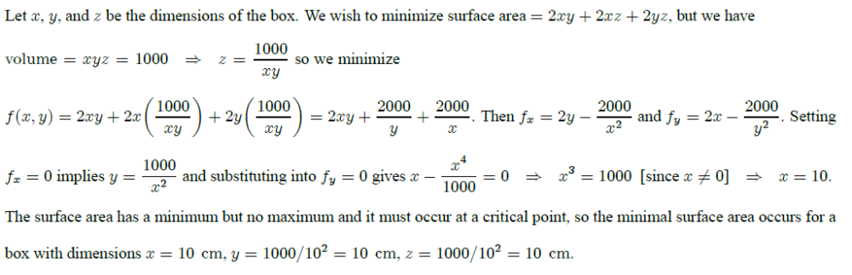

7. Each of these extreme value problems has a solution with both a maximum value and a minimum value. Use Lagrange multipliers to find the extreme values of the function subject to the given constraint
$$\left(a\right)f\left(x, y\right)=x^{2}-y^{2}; x^{2}+y^{2}=1$$
$$\left(b\right)f\left(x,y\right)=xe^{y};x^{2}+y^{2}=2$$

Solution
(a)
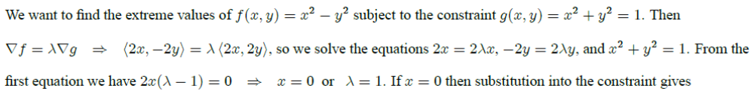
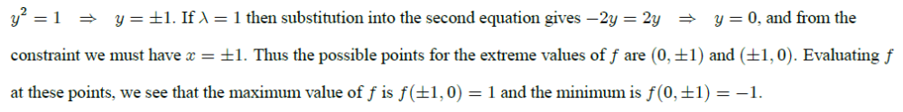
(b)
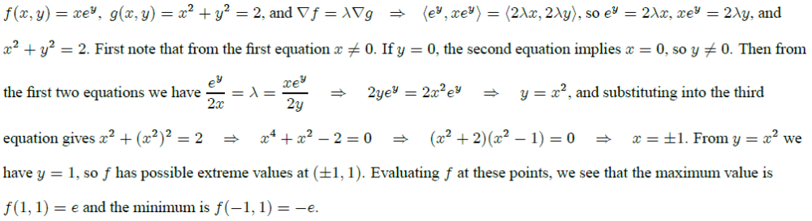
8. Find the extreme values of f on the region described by the inequality.
$$f\left(x, y\right)=2x^{2}+3y^{2}-4x-5; x^{2}+y^{2}≤16$$
Solution
